# COGS interface.

In order to be able to use historic (actual) costs for good sold in Promax PX, we need to load these historic costs into the system.Need to upload a CSV file once per period with the Standard COGS cost per case. This value is calculated by finance from the costs incurred in the previous period.

## Upload file definition

The spreadsheet is of the following format:

|  |  |  |
| --- | --- | --- |
| **PERIOD** | **ZREP_** | **COGS** |
| 201309 | 253713 | 11.50 |
| 201309 | 262460 | 62.74 |
| 201309 | 267464 | 30.27 |
| 201309 | 214501 | 14.14 |
| 201309 | 237255 | 10.39 |
| 201309 | 253293 | 27.48 |
| 201309 | 247347 | 20.04 |
| 201309 | 226122 | 15.05 |
| 201309 | 272086 | 0.89 |
| 201309 | 272087 | 4.66 |

This should be stored in VENUS (db1270p) in the PXI schema. The data in the file should be referenced by period, company code and division code.

## Table Definition

|  |  |  |  |
| --- | --- | --- | --- |
| **COLUMN** | **DATA TYPE** | **SIZE** | **EXAMPLE** |
| CMPNY_CODE | CHAR | 3 | 149 |
| DIV_CODE | CHAR | 3 | 149 |
| MARS_PERIOD | NUMBER | 6,0 | 092013 |
| ZREP_MATL_CODE | CHAR | 18 | 253293 |
| COST | NUMBER | 7,2 | 27.48 |
| LAST_UPDATE_DATE | DATE |  | SYSDATE |
| LAST_UPDATE_USER | CHAR | 30 | DREWCRA |

The upload should default the PXCompanyCode and the PXDivisionCode determined by the interface type:

|  |  |  |
| --- | --- | --- |
| **Company** | **PXCompanyCode** | **PXDivisionCode** |
| New Zealand | “149” | “149” |
| Petcare | “147” | “05” |
| Food | “147” | “02” |
| Chocolate | “147” | “01” |

New interface to Promax PX. This uses the off invoice actuals format.

The interface is to be sent weekly , if a material cannot be found in the cost standard table then the whole interface should fail, alerting to ANZ Apps support team.

Promax File Configuration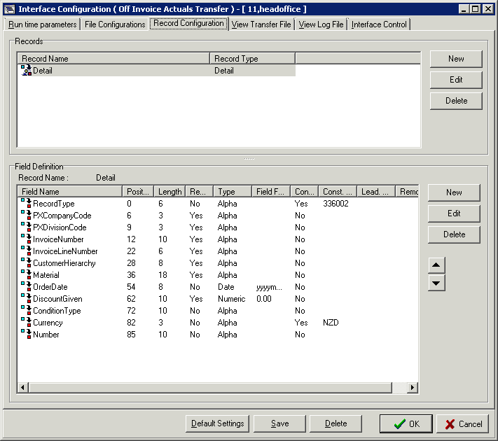

|  |  |  |
| --- | --- | --- |
| **Column** | **Description** | **Value** |
| RecordType | Record Identifier | 336003 |
| PXCompanyCode | Hard coded to New Zealand | “149” |
| PXDivisionCode | Hard coded to New Zealand market | “149” |
| InvoiceNumber | Invoice number from sales |  |
| InvoiceLineNumber | Invoice Line Number from sales |  |
| CustomerHierarchy  Material | Sold to code of the customer | Sold_to_cust_code |
| Material | ZREP Material Code | Rep_Item |
| OrderDate | Order date from the sale | nvl(decode(to_char(t2.order_eff_date,'DY'),'SUN',t2.order_eff_date +1,t2.order_eff_date),decode(to_char(t1.billing_eff_date,'DY'),'SUN',t1.billing_eff_date +1,t1.billing_eff_date)) as order_eff_date |
| DiscountGiven | Sale qty * standard from table | billed_qty_base_uom * COST joined by rep_item from matl_dim |
| ConditionType | Hard coded to cost type | “500” |
| Currency | Hard coded to New Zealand Dollars | “NZD” |
| Number | Left blank |  |

Interface will be scheduled to run weekly on a Sunday. The file should contain data for the previous full mars Week (Sunday to Saturday).

eg.

If run on Sunday 22nd September, the file should contain data for Invoices from Sunday 15th September to Saturday 21st.

If run on Saturday 21st September, the file should contain data for Invoices from Sunday 8th September to Saturday 14th September.

If a material cannot be found in the cost standard table then the whole interface should fail. It should raise an alert (email) to the ANZ applications support team.